Oracle 11.2.0.3 Software Install for boraw1q

Pre-Install

Run Prerequisite checker
##export DISPLAY=<your PC IP address>:0

xWindows Session

Start xStart
Method: SSH
Host: boraw1q.aetna.com
User: A id
Password:xxx
Command:/usr/bin/X11/xterm -sb -ls -display @d&@;

ipconfig to get local Ip address
export DISPLAY=10.114.14.208:0.0

cd /usr/lpp/X11/bin
xclock

export SOFTWARE=/orahome/wkab01/oracle11203_software
cd $SOFTWARE/DB/database

Step through installer only as far as the pre-requisite checker then exit. Due to the issue described in 1263513.1 we can’t run the checker in console mode.

Note: Make sure Exceed is started on your PC
./runInstaller
Answer “y” that rootpre.sh has been run by the root then in the installer window, do the following

- Click Next on the Configure Security Updates screen and answer yes, that you want to remain uninformed.
- On the Download Software Updates screen, Click the “Skip Software Updates” radio button then click Next
- On the “Install Options” screen, select “Install Database Software Only” and click Next.
- On the “Grid Install Options” screen, choose “Single Instance Database” and click Next
- On the “Product Languages” Screen, click Next.
- On the “Database Edition” screen, choose “Enterprise” and click Next.
- On the “Installation Location” screen, enter “/orahome/wkab01/app/oracle/product/11.2.0/db_3” and click Next.
- On the Operating System Groups screen it should say dba and dba. Click Next.
- Watch the prerequisite checks run and address any issues found. After fix, click “Check Again”. When done, click “Cancel” and answer yes that you want to exit.

The tcp/udp ephemeral low/high warnings are OK.

Got following Warnings:

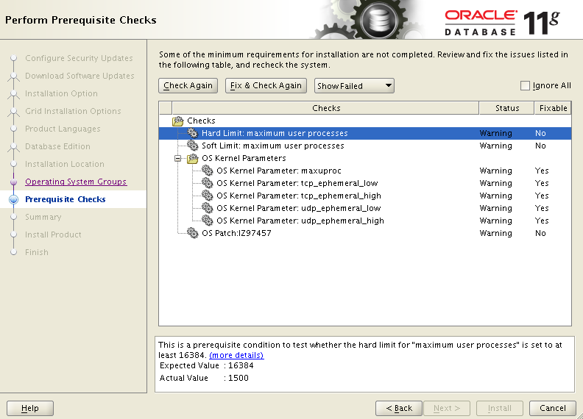

Based on all these warnings we can proceed with software Install/Cloning..

No need to wait. None of them have to do with the software portion of it. They would just affect running instances. The TCP/UDP things affect the range of ports that Oracle can use. The hard/soft process limits affect the number of processes a user can start up on the box. So you're good to proceed with the clone. The kernel parameters are really just a formality since we're already running instances there without problems. We just want to go ahead and change them so we don't have problems in the future with running out of ports or hitting the process limit.

Install Steps

Set environment
export SOFTWARE=/orahome/wkab01/oracle11203_software

Extract software to first Oracle Home location
cd $SOFTWARE
gunzip gold.tar.gz # if not already done
cd /orahome/wkab01/app/oracle/product/11.2.0
tar xvf $SOFTWARE/gold.tar
mv gold db_3

Set up oratab entries
vi /etc/oratab
- Create a norestart entry for db_3 named ORA11203_1 with the path as /orahome/wkab01/app/oracle/product/11.2.0/db_3
- Create a norestart entry for db_4 named ORA11203_2 with the path as /orahome/wkab01/app/oracle/product/11.2.0/db_4

Set ORACLE_HOME
Set the environment (don't use setupenv yet because it will access the ORACLE_BASE from the cloned home which isn't right yet)

export ORACLE_HOME=/orahome/wkab01/app/oracle/product/11.2.0/db_3
cd $ORACLE_HOME

Run clone on 1st home
Note: the following command is wrapped. It should be entered as one line.
$ORACLE_HOME/oui/bin/runInstaller -clone -silent -waitForCompletion ORACLE_HOME=/orahome/wkab01/app/oracle/product/11.2.0/db_3 ORACLE_HOME_NAME=OraDb_home3 ORACLE_BASE=/orahome/wkab01/app/oracle

This will take about 5 minutes. Check the output and review log (log name in shown in the output) to make sure there are no problematic errors

Please check '/boraw1qu01/app/oracle/oraInventory/logs/cloneActions2012-03-28_12-37-46PM.log' for more details.

You should see:
Install successful
and
The cloning of OraDb_home3 was successful.

Confirm oratab entry
. $SETUPENV ORA11203_1
Inspect output to make sure home and base are correct and that there were no errors.

Copy and edit network config files
cp /orahome/wkab01/app/oracle/product/11.2.0/db_2/network/admin/*.ora $ORACLE_HOME/network/admin

cd $ORACLE_HOME/network/admin

vi listener.ora
- Update all paths referencing the Oracle Home to be db_3
- Add the parameter to each wkab___ listener:
(SDU = 8192)
(TDU = 8192)
under the line “(SID_DESC =” to make this match prod

vi tnsnames.ora
- Clean up and remove any old entries

vi sqlnet.ora
- Remove SQLNET.EXPIRE_TIME= 10 if exists
- Change NAMES.DIRECTORY_PATH=(TNSNAMES, ONAMES, HOSTNAME) to NAMES.DIRECTORY_PATH=(TNSNAMES)
- Add SQLNET.INBOUND_CONNECT_TIMEOUT=15 to match prod

Create the link for TDP
cd $ORACLE_HOME/lib
ln -s /usr/tivoli/tsm/client/oracle/bin64/libobk64.a libobk.a
ls -l libobk.a

The output should read:
lrwxrwxrwx 1 oracle dba 46 Mar 27 21:47 libobk.a -> /usr/tivoli/tsm/client/oracle/bin64/libobk64.a

Create the 2nd Oracle Home
cd $ORACLE_BASE/product/11.2.0
cp -r -p db_3 db_4

Set ORACLE_HOME
Set the environment (don't use setupenv yet because it will access the ORALCE_BASE from the cloned home which isn't right yet)

export ORACLE_HOME=/orahome/wkab01/app/oracle/product/11.2.0/db_4
cd $ORACLE_HOME

Run clone on 2nd home
Note: the following command is wrapped. It should be entered as one line.
$ORACLE_HOME/oui/bin/runInstaller -clone -silent -waitForCompletion ORACLE_HOME=/orahome/wkab01/app/oracle/product/11.2.0/db_4 ORACLE_HOME_NAME=OraDb_home4 ORACLE_BASE=/orahome/wkab01/app/oracle
This will take about 5 minutes. Check the output and review log (log name in shown in the output) to make sure there are no problematic errors

Please check '/boraw1qu01/app/oracle/oraInventory/logs/cloneActions2012-03-28_01-24-39PM.log' for more details.

You should see:
Install successful
and
The cloning of OraDb_home4 was successful.

Confirm oratab entry
. $SETUPENV ORA11203_2
Inspect output to make sure home and base are correct

Update network config files
cd $ORACLE_HOME/network/admin
vi listener.ora
- Update all paths referencing the Oracle Home to be db_4

cp /orahome/wkab01/app/oracle/product/11.2.0/db_3/network/admin/*.ora $ORACLE_HOME/network/admin

Clean up Inventory
Clean up old 11.1 Homes
cd $ORACLE_HOME
Note: db_4 is fine just needs to be one of the new 11.2.0.3 homes.

$ORACLE_HOME/oui/bin/runInstaller -detachHome -silent ORACLE_HOME= /boraw1qu01/app/oracle/product/9.2.0a ORACLE_HOME_NAME="ORACLE_HOME"

$ORACLE_HOME/oui/bin/runInstaller -detachHome -silent ORACLE_HOME= /boraw1qu01/app/oracle/product/11.1.0/db_1 ORACLE_HOME_NAME="11gHOME1"

$ORACLE_HOME/oui/bin/runInstaller -detachHome -silent ORACLE_HOME= /boraw1qu215/app/oracle/product/11.1.0/db_2 ORACLE_HOME_NAME="11gHOME2"

view /boraw1qu01/app/oracle/oraInventory/ContentsXML/inventory.xml
Make sure those homes are gone or show as "REMOVED"

Also detachHome logs goes to /boraw1qu01/app/oracle/oraInventory/logs

cd /boraw1qu01/app/oracle/product/
mv 9.2.0a 9.2.0a.to_be_deleted

cd /boraw1qu01/app/oracle/product/11.1.0
mv db_1 db_1.to_be_deleted

cd /boraw1qu215/app/oracle/product/11.1.0
mv db_2 db_2.to_be_deleted

Check back after a week or so - if no problems reported then delete.

Run root.sh Note – this will be done as part of the relink
Have root user do the following:
cd /orahome/wkab01/app/oracle/product/11.2.0/db_3
./root.sh
Answer y when prompted to overwrites
cd /orahome/wkab01/app/oracle/product/11.2.0/db_4
./root.sh
Answer y when prompted to overwrite

